DER STEPPERMOTOR

23.09.2008 at 13:55:33
One of the often totally misunderstood items of the SPI engine is the stepper motor. In this bulletin we would like to explain what it does and how to adjust it to make it work properly.
The Rover ECU has an adaptive idle control buit in which aims at stabilizing the idle run of the engine. This is done by the stepper motor which opens and closes the throttle based on the signals received by the ECU. Maybe Hannes can provide some pictures he took during ums. development, giving a better impression of the mechanics.
In many cases when the SPI engine became faulty because of defect temp-sensors or false air supply, people didn't understood correctly that an increased idle speed was a circumstantial evidence of a Rover ECU running in its emergency program. Quite often the stepper adjustment screw was thought to be a kind of "idle speed adjustment" which is totally wrong and eliminated any possibility for the ECU to restore proper operation even after all other issues had been fixed.
The adjustment of the stepper adjustment screw is a factory setting, which should only be tampered with in case of a replacement of the stepper, throttle body or throttle position sensor. Once the adjustement has been changed, you'll need a Rover TestBook to tune it back to the necessary position ... if you haven't got an ums.!
The stepper motor needs to be adjusted in a way that he operates in the middle of his moving area. Misalignment leads to getting stuck at one of the endpoints of the moving area too early.
The ums. also has a built in closed loop idle control which can be adjusted in a wide range. However the ums. also needs to have the stepper adjusted properly. In the following we describe the procedure how you can check and adjust your stepper using the ums.
When turning on the ignition, the ums. drives the stepper from the totally closed position to the maximum position. This is a kind of reset, that the stepper always is at the desired position when starting the engine. This behaviour we will utilize for the adjustment process.
(1)
First we need to identify the absolute way the throttle can go. Therefor we start up Megatune for MS-Extra and bring the "TPS ADC" to the front of one of the gauges. This is the value of the Analog-Digital-Converter connected to the Throttle Position Sensor.
Have a look at the reading and note both the min value and the max value when pushing the accelerator all the way down.
Let's assume the min reading is 27 and the max reading is 209 (this are the values taken from my proper adjusted SPI)
(2)
With those numbers we can calculate the value for checking the stepper adjustement.
First we need to subtract the min value from the max value: In our example this means 209 - 27 = 182
The fully opened stepper should increase the min value by 15% to 16% , so in our example the increase should be 182 * 0,15 = 28 (Result was rounded up to the next integer).
This number we have to add to the min reading of 27 which means our result is 27 + 28 = 55
(3)
While you have Megatune still up and running and connected to the ums., turn on the ignition and watch the reading of the TPS ADC gauge. In our example the gauge should go up from the min reading 27 up to 55 and back to 27.
Please follow those three steps and redo the calculations with your own numbers and you will be able to check and adjust the stepper on your own. I would suggest only to modify the screw position in case your TPS ADC reading deviates significantly from the calculated value.
BR dougie Ralf
‘
As i promised before, i show some closeup pictures of the throttlebody and the stepper.
On the first one there can be seen the still built-in stepper motor plus the throttle pushrods.
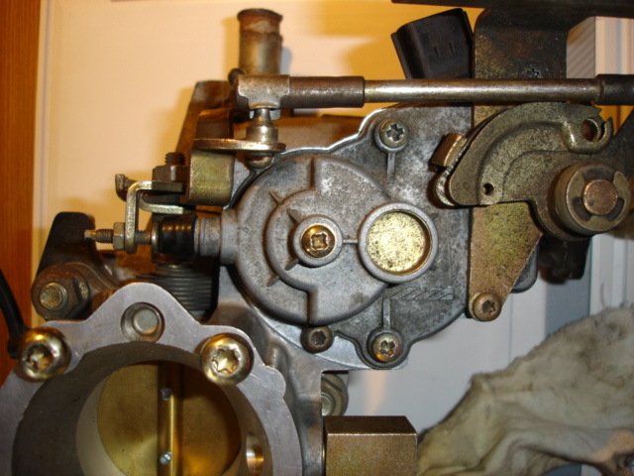
A closer look at the adjustment screw, which should not be touched unless you know what you are doing. The picture shows the slightly pulled out throttle pushrod - usually the adjustment screw should have contact with the steppermotor pin in idle mode
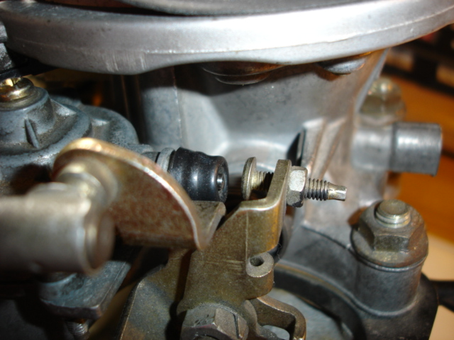
The stepper motor itself has a rotational gear which moves the retractor pin by means of an excentric pinion...
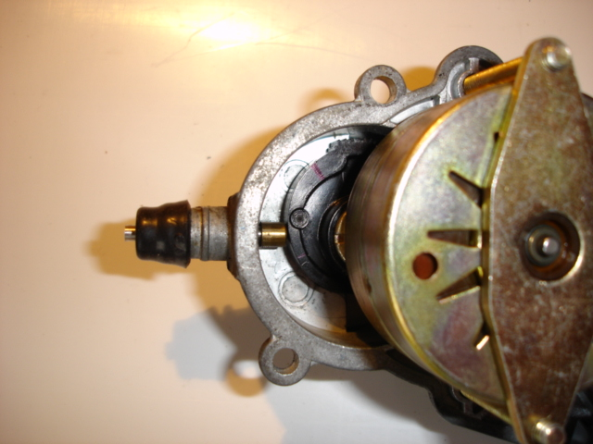
You should find that the stepper motor itself is okay - it's so okay in fact that it's taking the revs to 4000... You can test the phases of it with a multimeter. There are 5 wires going to it, 4 are all orange-and-something and the 5th is something else; that's the common. Measure resistance across each phase in turn, keeping one lead of your multimeter on the common wire and changing the other lead to the orange-and-somethings. They should all be roughly the same resistance.

OPERATION OF THE STEPPER MOTOR

The operation of the stepper motor. The theory of this should be very similar for the MPi if not the same, though the MPi stepper is an air bypass valve and not a 'throttle kicker' as in the SPi.
The stepper moror consists of four windings. All the windings are commoned together at one end, this is the 12+ve supply, Brown/Pink wire. The other four ends of the windings connect to the ECU. The ECU then grounds these in a certain sequence to drive the motor in steps, each one of a predetermined angle of rotation. The max number of steps of the SPi motor is in the region of 180
When you turn off the engine, you should hear an audiable clicking, this is the ECU driving the stepper fully closed. It drives it for 180 steps and a few more to make sure its closed, in doing this it knows where it is, zero steps, and can then count the steps open. After it has driven the steppper full closed and before the ECU switches off, It then opens the stepper to a point determined by the engine temp, ready for the next start. Once the engine is started it motors in relation to the engine temp and idle load of the engine. Idle speed is not directly controled by the steppper.
I normaly set the stepper up to show about 30 steps at warm idle with no load on the engine, IE no electrical devices on.
If one of the windings has not been working correctly, it misses a step in every sequence, but the ECU does not know this, so, say the ECU drives the stepper 40 steps from closed, what would hapen in reality is the stepper would move 30 steps. The engine will not respond as it should so the ECU will drive it some more, resulting in the Service tool showing a high step count. the control will become unsteady.
I have found a couple of the steppers to have dry soldered joints on the small connection PCB on the motor terminals. Its a simple fix, remove the stepper motor from its housing an re solder. Aslo worth checking that the winding resistances are all the same, if not, bin it and find another.
Corossion on the plug terminals is also an other possible, as you have seen. Id check the solder joints just to be sure

