A short description of how to wire in an ammeter or voltmeterfor your car.
The voltmeter also indicates whether the battery is being charged. A reading of ~12V indicates that there is no current flowing into or out of the battery. Less than 12V indicates discharge (typically 8V when cranking the starter) and 13-14V is a healthy charging voltage.
More than 15V when charging indicates a faulty regulator on the alternator.
A voltmeter actually shows more information than the ammeter, and is also safer to wire in since it takes no current and this allows the use of a small (1A or less) fuse.
Here's an artistic pic. of how both could be wired in.
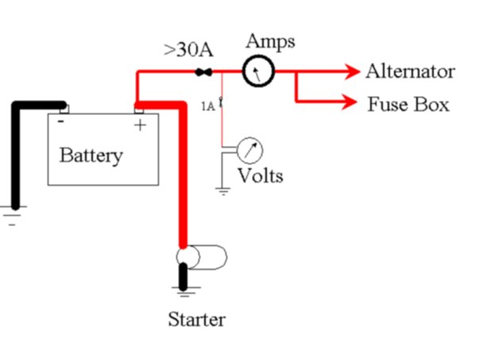
*This document is copyright Sean Houlihane,1998-2001, and may only be reproduced in full with acknowlegements, or referenced as a link*

