Rear Radius Arms, Cone Suspension ( Dry )
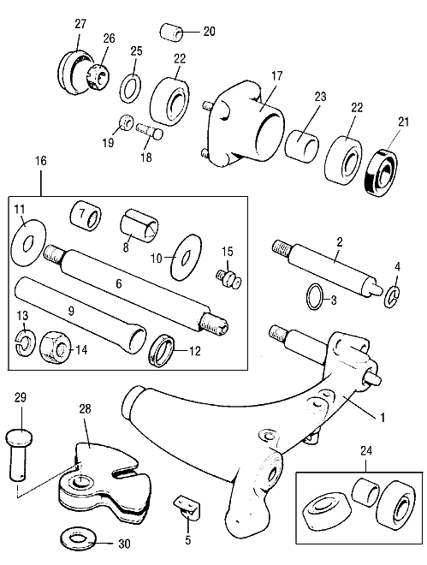
No. | Part No. | Description | Qty | Remarks
1 | NAM7162 | Swing arm R/H | 1 | was 21A392
1 | 21A392/R | Swing arm, R/H, rebuilt | 1
1 | 21A393/c | Swing arm, R/H, complete with brake assembly | 1
1 | NAM7163 | Swing arm, L/H | 1 | was 21A393
1 | 21A393/R | Swing arm, L/H, rebuilt | 1
1 | 21A393/C | Swing arm, L/H, complete with brake assembly | 1
2 | 2A7351 | Radius arm stub axle R/H | 1
2 | 2A7364 | Radius arm stub axle L/H | 1
3 | CUD1173 | Seal on stub axle for NAM7162/3 only | 2
4 | 2A7352 | Stub axle circlip | 2
5 | 21A397 | Bracket on radius arm for hose | 2
6 | ACA9099 | Pin | 2
7 | ATJ4098 | Roller bearing inner, was 13H442 | 2
8 | 2A7325 | Bronze bush outer | 2
9 | 21A396 | Metal grease sleeve, being replaced by plastic sleeve | 2
10 | 2A7324 | Outer thrust washer | 2
11 | ACA9302 | Inner thrust washer | 2
12 | 2A7327 | Sealing rubber ring | 4
13 | LWZ208 | Spring washer | 4
14 | FNZ508 | Nut | 4
15 | UHN400 | Grease nipple | 2
16 | GSV1125 | Radius arm repair kit | 2
17 | 21A2023 | Hub with studs | 2
17 | 21A1277 | Hub with long studs, 'S' and 1275GT plus all 1984 on | 2
18 | 21A2064 | Wheel stud, shaft length 1.375" 35mm | 8 | Thread length 0.875"
18 | 21A2064L | Wheel stud, shaft length 2.000" 50.80mm | 8 | Thread length 1.125"
18 | ATA7085 | Wheel stud, shaft length 1.6875" 42.65mm | 8 | Thread length 1.000"
18 | 21A1278 | Wheel stud, shaft length 2.375" 60.30mm, Cooper S Length | 8 | Thread length .750"
18 | ENJO-1039 | Wheel stud, shaft length 2.375" 60.30mm | 8 | Thread length 1.125"
18 | ERA1268 | Wheel stud, shaft length 2.437" 62mm | 8 | Thread length 1.000"
19 | 88G322 | Wheel nuts, round radius chamfer angle | 16
19 | 113087 | Wheel nuts, 60° chamfer angle | 16 | Steel wheel 1985 on
20 | CN1 | Chrome wheel nut | 16 | Alternative to 88G322
20 | CN4 | Chrome wheel nut, wide base | 16 | Alternative to 88G322
20 | AHA8785 | Chrome wheel nut, 60° chamfer dome - 1275GT Rostyle | 16 | Weller steel, use CN2
20 | CN2 | Chrome wheel nut, 60° chamfer angle | 16 | Weller steel and Rostyle
20 | CN5 | Chrome wheel nut, wide base | 16 | Alternative to CN2
21 | GHS134 | Metal backed 'S' oil seal | 2 | Use GHS102
21 | GHS102 | Hub oil seal | 2
22 | GHB116 | Bearing without built in spacer | 4 | NLA, use GHK1088
22 | GHB212 | Bearing with built in spacer | 4 | Part of GHK1088
23 | 2A7354 | Spacer when GHB116 fitted (Not Timken) | 2
24 | GHK1352 | Ball bearing kit with built in spacer and seals | 2 | was GHK1352
24 | GHK1548 | Timken tapered roller bearing set with seals | 2
25 | BTA672 | Hub washer | 2
26 | NL610041 | Hub nut R/H | 1
26 | FNN2410 | Hub nut L/H | 1 | Left hand thread
27 | ATB4098 | Grease retaining cap | 2
28 | 21A2454 | Hand brake quadrant | 2
29 | CLZ549 | Clevis pin, was BH605281 bolt | 2
30 | AWZ105 | Washer | 2

