RADIATOR ALUMINUM 2 CORE PRE 1990
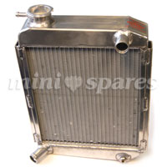
  Price | £185.00 exc vat
   | £217.38 inc vat
  For: Classic Mini
  Part No. C-ARA4441
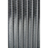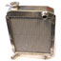
Description
Side mounted as per all pre 1996 cars this is a super cool lightweight alloy radiator BUT FOR PRE 1990 cars as it has the overflow pipe facing backwards. for 1990 on cars with a 1275 engine use C-ARA4441A which has the overflow pipe facing forward for the expansion tanks which were fitted as standard

